INDUSTRIALIZED BUILDINGS COMMISSION 505 Huntmar Park Dr., Suite 210, Herndon, VA 20170 |  |  |  |  |  |  |  |  |  |  | Page of
MONTHLY PRODUCTION REPORT |  |  |  |  | Facility Name:
Production Period (mo./yr.): |  |  |  |  | Location (City, ST):
Inspection Agency: |  |  |  |  | Authorized Rep.:
List of labels in inventory:
IBC Label Number | Model Designation | Sys. (Y/N) | Serial Number | Date of Manufacture |  | Module Number | Use Group | FIRST LOCATION Name | INFORMATION City State
 |  |  |  |  |  | /
 |  |  |  |  |  | /
 |  |  |  |  |  | /
 |  |  |  |  |  | /
 |  |  |  |  |  | /
 |  |  |  |  |  | /
 |  |  |  |  |  | /
 |  |  |  |  |  | /
 |  |  |  |  |  | /
 |  |  |  |  |  | /
 |  |  |  |  |  | /
 |  |  |  |  |  | /
 |  |  |  |  |  | /
 |  |  |  |  |  | /
 |  |  |  |  |  | /
 |  |  |  |  |  | /
 |  |  |  |  |  | /
 |  |  |  |  |  | /
INSTRUCTIONS -- IBC MONTHLY PRODUCTION REPORT
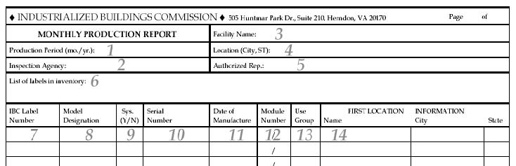
Type or print legibly!
- Production Period - month and year for which report is being filed.
- Inspection Agency - name of IBC designated inspection agency who issued the labels. A separate report is required for each inspection agency that operates in that facility.
- Facility Name - name of manufacturing facility that produced the modules. A separate report is required for each manufacturing facility.
- Location - city and state where manufacturing facility is located.
- Authorized Rep. - name of manufacturer’s representative who is responsible for the information provided in the report.
- List of Labels in Inventory - list of IBC label serial numbers that are assigned to the facility but that have not been affixed to a module as of the last day of the production period.
- IBC Label Number - complete serial number of the IBC label affixed to the specified module.
  - 8. Model Designation -
  - a. For individually approved floor plans, manufacturer’s designation as it appears on the set of plans submitted to the evaluation agency. Each individual floor plan must have a unique model designation.
  - b. For floor plans derived from an approved building systems set, the title of the set such as Ranch, Two-Story and Cape Cod and the overall size of the building (see item 9).
- * NEW! * Sys. (Y/N) - enter “Y” if plans were derived from an approved building systems set.
- Serial No. - serial number assigned to the module in accordance with the manufacturer’s compliance assurance manual. Serial numbers on monthly production reports must match the ones shown on inspection agency inspection reports.
- Date of Manufacture - date IBC certification label was affixed to the module.
- Module Number - module number per total number of modules in the building (1/4, 2/4, etc.)
- Use Group - group in which the structure is classified based on use or occupancy as defined in applicable building code.
- FIRST LOCATION INFORMATION Name, City, State - name of person, builder or developer to whom the module has been or will be shipped and city and state where the module will be located. When known, final destination of the module must be provided.

